  

HAWASSA UNIVERSITY

WONDOGENETCOLLEGE OF FORESTRYANDNATURALRESOURCE

DEPARTMENT OF GEOGRAPHIC INFORMATION SCIENCE (GISc)

SENIOR RESEARCH ON WATERSHED BASED LAND USE LAND COVER CHANGE ANALYSIS IN WONDO GENET CATCHMENT.

SUBMITED BY: CHILOT DEMEKE

SUBMITED TO: Mr. FIREHIWOT GIRMA

JANUARY 2023 WONDO GENET, ETHIOPIA

**Table of Contents**

1 Introduction 1

1.1 Background of the study 1

1.1.1 General objective 2

1.1.2 Specific objectives 2

1.1.3 Research question 2

1.1.4 Significance of the study 2

2 Literature Review 3

2.1 Concept of Land Use and Land Cover 3

2.1.1 Land Cover Mapping 4

2.1.2 Land use and land cover change detection and watershed 4

3 Methodology 5

3.1 Description of the study area 5

3.1.1 Geographic location 5

3.1.2 RAINFALL 5

3.1.3 CLIMATE 6

3.1.4 SOIL 6

3.1.5 Vegetation 6

3.1.6 POPULATION 7

3.1.7 LAND USE 7

4 Materials and Method 8

4.1 Satellite /Remotely sensed Image 8

4.2 Material used 8

4.3 Methods 9

4.4 Data collection 9

4.4.1 Primary data 9

4.4.2 Secondary data 10

4.5 Data analysis procedures 10

4.5.1 Image enhancement 11

4.5.2 Image classification analysis 11

4.5.3 Unsupervised classification 12

4.5.4 Supervised classification 12

5 RESULTS AND DISCUSSION 14

5.1 RESULTS 14

5.2 Landsat 5 Data for 1990 Images 14

5.3 Landsat 8 Data for 2012 Images 15

5.4 Landsat 8 Data for 2023 Images 17

5.4.1 LAND USE LAND COVER CHANG ANALYSIS 18

5.5 Major Causes of LULCC 24

5.5.1 Natural Variability 24

5.5.2 Demographic Factors 25

5.5.3 Cultural Factors 25

5.6 DISCUSSION 25

6 Conclusion and Recommendation 26

6.1 Conclusion 26

6.2 RECOMMENDATIONS 26

7 Reference 27

Figure

Figure1: Watershed 5

Figure.2: Flow Chart Of The Methods Of Lulcc 13

Figure 3: Land use land cover map of Wondogenet in 1990 14

Figure 4: Land use land cover map of Wondogenet in 2012 16

Table 5: LULC Class Distribution of wondogenet in 2023 17

Figure 6: Land use land cover change map of wondogenet woreda from 1990 to 2012 19

Figure: area as chart 20

Figure:rate as chart 21

Figure 7: Land use land cover change map of wondogenet woreda from 2012 to 2023 22

Figure 8: Land use land cover change map of wondogenet woreda from 2012 to 2023 23

Table

Table.1: materials needed for this study area 9

Table 2: LULC Class Distributions of Wondogenet in 1990 15

Table 4: LULC Class Distribution of wondogenet in 2012 16

Table 5: LULC Class Distribution of wondogenet in 2023 17

Table 6: LULC Conversion matrix for the year 1990 to 2012 20

Table7: LULC Conversion matrix for the year 2012to 2023 22

Table8: LULC Conversion matrix for the year 2012to 2023 24

ACKNOWLEDGMENT

I would like to express my deepest gratitude and sincere thanks to my advisor Mr. FIREHIWOT GIRMA for his immeasurable and priceless support, constructive criticism and devoting precious time in reading, guiding, as well as correcting of this research project, without whom this paper would not be in its present form.

Furthermore, I would like to thank my friends and classmates and others whose name is not listed here for their support and suggestions.

Finally, my heartfelt thanks go to my family for their support and encouragement during my project work and to all others who directly or indirectly contributed to the success of the study.

Abstract

The aim of this study is to investigate and understand land Use and land cover change in Wondo genet catchment that have been taken times between in 1990,2012 and 2023.

Land-use change is one of the main drivers of environmental change. Its impact on soil often occurs so sweepingly that land managers hardly contemplate initiating ameliorative or counterbalance measures. Common to all is that there are impacts on sustainability of the natural systems on which productivity depends. There is an urgent need for a regional framework and guidelines for sustainable land management including all sectors of land use like cropping, grazing and urbanization. This paper highlights some of the changes in land use in the study area, presents the implications of these changes on productivity. The area computed shows that there in an increase is urban, vegetation in land use land cover change and the decrease are agriculture, bare land, in land use land cover change from the year 1990, 2012 and 2023 years.

**Key words:**

ABBREVIATIONS LIST OF ABBREVIATIONS

**GIS**  Geographic information system

**LMSS**  Land Sat Multispectral Scanner System

**LULCC**  Land Use Land Cover Change

**LULC**  Land Use Land Cover

**ETM** Earth Topographic Maps

**TM**  Thematic Map

**NDVI** normalized difference vegetation index

CSA Central Statistical Agency

**SNNP**  south nation nationality of people

WGWOA Wondo genet woreda office of agriculture

DEM digital elevation model

FCC False color composite

# Introduction

## Background of the study

LUCC is a very complicated process, affected by natural and human dimensions. The natural environment is a dominant factor in a way, while human dimensions.LUCC is a basic precondition of regional LUCC monitoring, driving factor analysis, and even to lulcc prediction.RS (remote sensing) and GIS (geographic information systems) are believed as the most advanced means to obtain land use information because they are real time, impersonal and has wide coverage. It is essential component where in other parameters are integrated. On the requirement basis to drive various Developmental index for land and water resource in Wondogenet woreda. Land use refers to man’s activities and the varied uses which are carried on over land use and It also refers to natural vegetation, water bodies, rock/soil, artificial cover and others noticed on the land. Land use land cover is the observed physical and biological cover of the earth land as vegetation or man-made feature. In contrast land use is the total of arrangements, activities and inputs the people under take in certain land cover type (Ali Hussein, 2009).Land use/land cover (LULC) changes play a major role in the study of global change. Land use/land cover and human/natural modifications have largely resulted in deforestation, biodiversity loss, global warming and increase of natural disaster-flooding. These environmental problems are often related to LULC changes. Therefore, available data on LULC changes can provide critical input to decision-making of environmental management and planning the future. Changes Future: Changes in land use are most cases, reflection of the dynamic socioeconomic development and natural forces mainly aggravated by increasing population and agriculture is seen as the major driver of this change (Behailukebede, 2006).Some of the consequence of land use land covers changes in biodiversity loss, climate changes, pollution and other environmental impacts of LULC include the destruction stratospheric ozone by nitrous oxide release from agricultural land and altered regional and local hydrology (Dum constriction ,water land drainage, irrigation projects, increased impervious surface in urban areas)( E.F.Lambine, B.L. Turner, 2000). Statement of the problem Land use land cover (LULC) is dynamic in nature. But various process influences the speed of change, the distribution and the type of land use land cover. However, in the past time no research had been conducted on the study area. Hence it is difficult to know the land use land cover change of the area due to lack of relevant information on this issue. The natural forests on mountain slopes around Wondo Genet are sources of many springs and  
rivers. Besides the prevalence of hot springs at the bottom of the mountains there are four  
main rivers namely Wesha, Werqa, Lango and Hallo and these rivers flows throughout the  
year and they provide the opportunity to provide farm irrigation. The water from  
these springs and streams support not only the farming community in the area but also the  
urban dwellers in the nearby towns, such as Shashemene since 1974 (Zerihun Mohammed,  
1999). Lake Cheleleka is another water body found in the study area it partly comprises  
uncultivated marshy and surrounded by rocky hill side in the north.

### General objective

* The aim of this study was to investigate and understand land Use and land cover change in Wondo genet catchment that have been taken times between in 1990,2012 and 2023

### Specific objectives

* To produce map watershed-based land use land cover change in the study area.
* To examine the level of change the area in 33 years periods of (1990, 2012 to2023)
* To delineate watershed boundary of Wondo Genet catchments from DEM (SRTM 30m)

### Research question

* What is the map watershed based LULC analysis of in Wondo genet catchment?
* How to analysis the level of change the area in this period 33 years?
* How Land cover classes are typically mapped from digital remotely sensed data through the process of a supervised digital image classification?

### Significance of the study

Land use land cover change is directly impact biotic diversity of the earth. The need for improved methods for resource management and environmental hazarded assessment is acute in areas. This work presents recent estimates of the rates in change of major land use classes, such as forest, crop land and pasture. Among the causative mechanisms behind land change synergetic factor combination are found to be more common than single key factor explanation. It has been universally observed that the rapid growth of population and extension of agriculture’s activities in the catchment to support the growing population have pre round consequence for the environmental degradation in the area. Therefore, in order to provide spatial information for the people to understand the causes and effects of land use land cover change.

# Literature Review

## Concept of Land Use and Land Cover

The understanding of land-use/land cover change has moved from simplicity to realism and complexity over the last decades. In the beginning, the studies were concerned mostly with the physical aspect of the change, but later, in the research agenda on global environmental change (Otter man, 1974; Chaney and Stone, 1975; Sagan et al. 1979). Scientists realized that land surface processes influence climate because of the land use/cover change. In mid1970s, it was recognized that land cover change modifies surface albedo and thus surface atmosphere energy exchanges, which have an impact on regional climate (Otter man, 1974; Chaney and Stone, 1975; Sagan et al. 1979). Much broader range of impacts of land-use/cover change on ecosystem, goods and services were further identified. Of primary concern are impacts on biotic diversity worldwide (E.F.Lambine, B.L and H.J.Geist, 2006), The environmental consequences of LULC activities include effects on biodiversity, land and water resources (Mother, 2003).Delineation of different land use land cover type on photogrammetric made from visual interpretation of characteristics (e.g. tone, texture and color) aided by optical device (Andrew skid more, 2003).There changes encompass the greatest environmental concerns of human population of water, soil and air, monitoring and mediating the negative consequence of land use land cover changes while sustaining the production of essential resources has therefore become major priority of researchers and policy makers around the world (E.F.Lambine, B.L and H.J.Geist, 2006).

Land use and land cover change very often due to the growing population and economy. In human history land, a fundamental factor of production has been coupled to economic growth (Robert T.Wateson, 2000). Land cover changes are controlled by human interactions. Land use affects land cover and changes in land cover affect land use. A change in either, however, is not necessarily the product of the other. Changes in land cover by land use do not necessarily imply a degradation of the land. However, many shifting lands use patterns; driven by a variety of social causes, result in land cover changes that affect biodiversity, water and radiation budgets, trace gas emissions and other processes that, cumulatively, affect global climate and biosphere (E.F.Lambine, B.L and H.J.Geist, 2006). The main factor that causes land use changes is human demand for physical resources, technological expansion and institutional capacity to produce and consume such resources.

In Africa, native vegetation including woodlands and grasslands have increasingly been converted to farmlands (Diouf & Lambin, 2001; Millennium Ecosystem Assessment, 2005). Similarly, there has been a continuous conversion of forests to farmlands in Ethiopia since the 1970’s (Reusing, 2000; Tadesse, 2001; Biazin & Sterk, 2013). Since the last four decades, the expansion of crop lands has gone to marginal lands of the Ethiopian high lands that are prone to land degradation (Zeleke & Hurni, 2001; Moges & Holden, 2009; Gebrehiwot et al., 2010; Biazin & Sterk, 2013). The annual rate of deforestation in Ethiopia is 1.1% of the remaining forest area.

### Land Cover Mapping

Land cover mapping is one of the most important and typical applications of remote Sensing. Initially, the land cover classification system should be established, which is usually defined as levels and classes. The level and class should be designed in consideration of the purpose of use (national, regional or local), the spatial and spectral resolution of the remote sensing data, user’s request and so on Japan Association of Remote Sensing (1996). According to Jensen (1996), there is a fundamental difference between information classes and spectral classes. Information classes are those defined by men while spectral classes are those inherent in the remote sensing data and must be identified and labelled by the analyst. The aim of digital classification is to translate spectral classes into information classes (L.O.Leemans, and R. 1995).

### Land use and land cover change detection and watershed

Major land use changes in the Wondo Genet catchment occurred in the period between 1986 and 2011. In the Wondo Genet catchment, there are natural vegetated areas, which are open bush land, natural forest, rangeland and wetland, small and large agricultural fields and water bodies. Open bush land mainly covered by grassland, bushes and some trees. Natural forest consists of mixed type, dense forest in this area. Rangeland is mainly grassland which is used for grazing. Small agricultural fields (< 2 Ha) are smallholder farms with usually intercropping systems and with crops which are cultivated multiple years, whereas large agricultural fields are mainly dominated by commercial agriculture with monoculture cropping systems. The wetland cover is the swamp area, which is a fluctuation between grass and water cover (Nega emiru, HelufGebrekidan and Degefa Tibebe, 2003).

# Methodology

## Description of the study area

### Geographic location

Wondo Genet watershed is located between 380 37’ to 380 42’longitude east and 70 02’ to 7007’latitude north, South Ethiopia. It is part of Hawassa watershed, situated in the eastern Boundary of the southern rift valley and is located at about 265km from the capital city, Addis Ababa. The watershed starts in less than 10 km from the main commercial Centre, Shashemene town. It is also located near to Hawassa, the SNNP State’s capital. Owing to the Favorable climatic conditions and good quality of agricultural natural resources, the area is Very conducive for production of cereals and perennial crops as well as animal husbandry (Zerihun, 1999; Teshale Woldeamanuel, 2003).

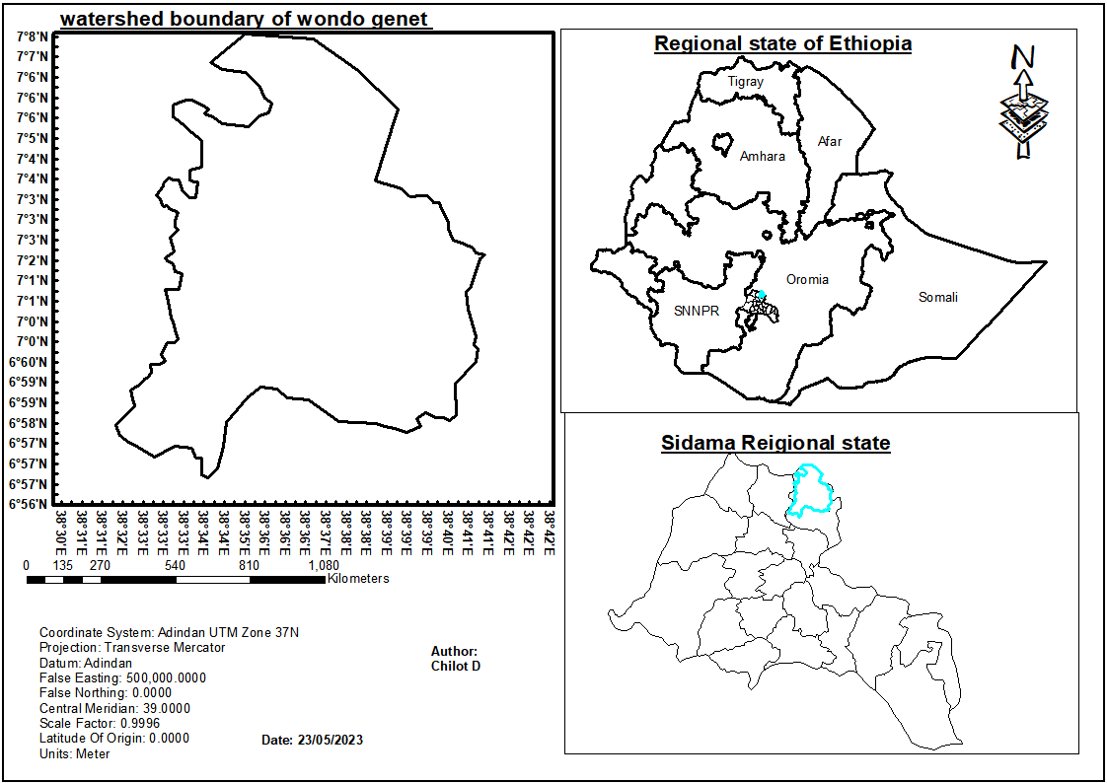

Figure1: Watershed

### RAINFALL

The rainfall distribution of the study area was bi-modal .The climate in Wondo Genet was characterized by two rainy seasons, a long rainy season from June to September and a short rainy season from March to May. Short rain falls during spring and the major rain comes in summer and stays for the first two months of autumn season

The total annual rainfall range was between 800 mm to 1600 mm. On the other hand, average annual temperature varies between 18°C and 21°C. (Ali Mohammed 2007,, (Girma et al. 2017; Hunde et al. 2003).

### CLIMATE

The study area was categorized under Dega agro-ecological zone at the upper part of the area (Includes:Watara-Gendo, Babo-Chororo, Gike-Gina, Gike-Ataye and Baja-Gemechokebeles), and Wayne Dega agro-ecological zone at the lower part of the area (includes: Chuko, Baja, Edo, Aruma, Yuwo, Awaye, Wotera-Kechema, WoshaSoyoma, Kola 01, Buda, Entaye, Shashana-Kekele, and Goton-Omuwakebeles) The annual temperature ranges between 17°c and 19°c. The main rainy season occurs between June and October with the maximum monthly fall occurring in July. The short rains that contribute up to 28%of the annual rain fall are in the period march to May. The dry season extends from November to February, with December and January being the driest. In general, the climatic condition of the area is suitable for production of both common food and cash-crops (Wondo Genet office of agriculture, 2014).

### SOIL

Soils of Wondo Genet were loamy sand textured generally well supplied with all available plant nutrient except phosphate (Makin et al., 1975). The soil depth was shallow on steep slopes and on flat and gentle slopes it reaches up to 4m (Erikson and Stern, 1987). Even though it was decreasing, Wondo Genet was well endowed with rich agricultural natural resource. Fertile soil suitable for the production of both cereal and perennial crops was one of the major endowments of the area. Although the uncultivable lands (marshy, stony and hilly lands) constitute a significant proportion of the total land size, the quality of the remaining arable land was very good characterizing Wondo Genet as one of the most productive areas of the region. (Makin et al., 1975)

### Vegetation

Wondo Genet has different types of exotic plantation forest managed by Wondo Genet collage of Forestry and Natural Resources and Mensa Shashemene Forest Enterprise (MSFEs) and the essential Oil Research Institute. Small patches pockets of high forest, with common species Afro carpus falcate, prumus Africana, Albiza gommifera, Aninjeria and croton macrostachyus, can be observed at the foot of mountain (Abaro).with decreasing altitude, open Acacia wood land also occurs (A.W.Kuchler and I.S.Zonneveld, 1988)

### POPULATION

Based on the 2007 population and housing census of Ethiopia, the total population of the Study area was 144,744 with an average of 6 persons per households. Out of these, 70,864 are male and 73,880 females. The ethnic groups reside in the area includes Sidama, Oromo, Wolaita,Kambata, Hadiya and others (Wondo Genet agency of agriculture and Kebele administration in Shashe Kebele, 2014). Besides the natural increase in population, migration was the other major Factor for the high population density in the area. According to the Wondo genet woreda office of agriculture (WGWOA) the total population of the woreda in 2005 was 122,826 out of which 20988 were urban and the rest 101841 are rural.(Wondo Genet agency of agriculture and Kebele administration, 2011).

### LAND USE

The livelihood of the people in the area depends mainly on mixed agriculture (crop-livestock production). Specifically, about 78% are engaged in subsistence farming system that involves simultaneous crop cultivation and livestock rearing. Only 22% of the households are engaged in sole crop production. The farm was both rains fed and seasonally irrigated. The size of farmland individual holdings range between 0.25 and 1.0 ha and on average a farmer owns 0.6 ha of land. The majority of the households (97%) cultivate their entire land holding (Wondo Genet agency of agriculture and Kebele administration in Shashe Kebele, 2014). The major crops cultivated in the area are cash crops such as chat, Inset, coffee, sugarcane, banana, avocado and papaya. These crops used as source of income and food. Besides, cow, ox, donkey and calf are also some of the animals reared. These animals used as a source of cash income, food supply to households, animal dung for land fertilization and serve to transport goods and people( Erle Ellis, 2010).

# Materials and Method

## Satellite /Remotely sensed Image

These were the product of space born remote sensing satellite. They provide the information about the earth surface and its surface. In our study of land use land cover change of Wondogenet would be use two different satellite images which were taken at different times of the same place. These remotely sensed images can provides data on parameters that were well correlated with the information visible on images viewed from above, several atmospheric and biosphere factors at the time of imaging essential information. Add the only software that you would use for the research. Remove the hardware part discussion and Remove the following table. Clearly show the types of sensor and their source (American museum of natural history, 2004)

## Material used

These were the components of GIS and computer parts. The hardware part of computer was in which we can touch it. Their includes processer, memory, high resolution color grapier screen, and data input and output devices like digitizer, scanners, keyboard, printers, plotter, CDs etc. likewise there were also number of essential software elements that allow users to input data, store, manage, transforms, analyses and output data. That was why the software and hardware part of computer are interdepend able.

Generally materials needed for this study area listed as follow in table,

|  |  |  |  |  |
| --- | --- | --- | --- | --- |
| Material | | | Purpose | Sources |
|  | Hardware | Computer  GPS  USB cable | For all data processing and analysis  To collect point data  To download GPS data in to computer | Open sources |
| Software | Arc GIS  Arc catalog  QGIS  MS WORD  MS EXCE | To analyses data For data management  To correct rectify, classify, etc.  to make lulc change  Word processing  statistical analysis and Chart and graphs preparation | Open sources |
|  | Data | Topographic data  Landsat 8 sentinel2  DEM | To delineate watershed boundary  To classify lulc type  Used for to generate watershed delineation | /EMA/ Ethiopia map agency  GLCF/ USGS online source  From Google earth engine |

Table.1: materials needed for this study area

## Methods

## Data collection

Before the spatial analysis would be carried out all the input data would be identified and collected. The relevant data which would have been collected for this study was both primary and secondary data type.

### Primary data

The primary data would be collected for this study be field visit. The primary data for this study was include observation data and GPs field survey which was used for testing the accuracy of classification, assisting in the analysis of change, to identify areas to be used for further analysis and accuracy assessment and verification.

### Secondary data

The secondary data will be collected for this study will be includes:

* Satellite image collected at different time,
* Land sat TM image,
* Map of the study area which will be used for accuracy assessment,
* Identifying the training site and,
* The other secondary data.

## Data analysis procedures

To completes the all process of watershed boundary by using Wondo genet DEM in ArcGIS10.3.1. Watershed analysis refers to the process of using DEM and raster data operations to delineate watersheds and to derive features such as streams, stream network, catchment areas, and BASIN etc. Watershed has 8 Steps

Find DEM data.

Fill Sinks.

Flow direction.

Flow accumulation.

Project Outlet Point.

Extract Coordinates of Outlet Point.

Generate Watershed.

Raster to Vector.

Then that used to for boundaries of LULC from satellite image extents. Initially a land sat TM image of this study area was extracted from the satellite image and pre-processed and then classify the different land use land cover types using QGIS3.22.1,

Step Data

* Install required software.
* Find our QGIS user profile directory.
* Use Plugin Builder to generate the plugin template.
* Create the user interface in QT Designer.
* Edit the plugin template to include our Python script.
* Test the functional plugin.
* Data pre-processing

Raw satellite image are full of errors and cannot directly utilized for features Identification or used for any applications. This process involves of two major processes: geometric correction and radiometric correction or haze correction. Remote sensing imageries the subjected to the geometric distortions. This may be due to the perspective of the sensor optics, the motion of scanning system, the terrain relief, and the motion of the platform which is the platform of altitude, attitude and velocity. This process are aim to correct the distorted data in order to create more clear representation of the original scene, this more involves the initial of raw image data to be correct for geometric distortions, to calibrate the data radiometric ally and eliminate noise present in the data.

### Image enhancement

Image enhancement is used to increase the detailness of the image by assigning the image maximum and minimum brightness values to maximum and minimum display values, and it is done on pixel values, and this makes visual interpretation easier by increasing the visual discrimination between features in a scene and assists the human analyst: False color composite (FCC), spatial re-sampling, etc.

### Image classification analysis

Image classification is the process of creating thematic maps from satellite imagery. A thematic map is an informational representation of an image that shows the spatial distribution of a particular theme. In this study, unsupervised and supervised classification methods will be used

In supervised classification the user or image analyst “supervises” the pixel classification process. The user specifies the various pixels values or spectral signatures that should be associated with each class. This is done by selecting representative sample sites of a known cover type called Training Sites or Areas. Procedures of supervised classification as follow:

* Supervised Classification
* Create training input
* Create classes
* Change Band Rendering
* Create ROIs
* Assess ROIs
* Run classification
* Change detection
* Results

### Unsupervised classification

Unsupervised classification technique would be performed when there was little or no knowledge to the geography of the region where classification is under taken. Therefore, first the satellite image was classified in the unsupervised classification for identification of the features in a pixel form. Then by observing and recording identifiable coordinate points of features in the Google Earth were perform the supervise classification using the training point.

### Supervised classification

Supervised Classification algorithms such as:

•Random Forest

• Maximum likelihood

• Minimum-distance

• Principal components

• Support vector machine (SVM)

• Iso cluster

The delineation of training areas representative of a cover type was most effective when an image analyst has Knowledge of the geography of a region and experience with the spectral properties of the cover micro classes.

The flow chart of the methods will be in the following:

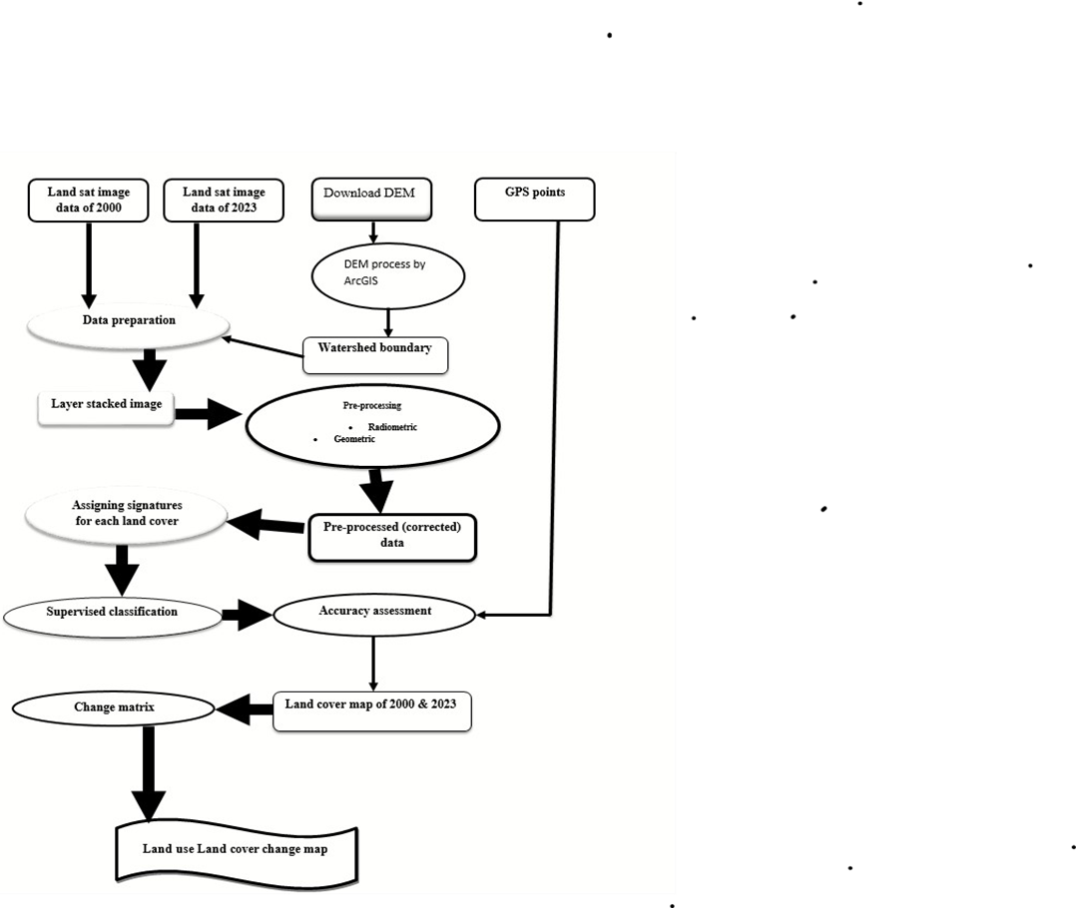

Figure.2: Flow Chart Of The Methods Of Lulcc

# RESULTS AND DISCUSSION

## RESULTS

Land cover classes are typically mapped from digital remotely sensed data through the process of a supervised digital image classification. The overall objective of the image classification procedure is to automatically categorize all pixels in an image into land cover classes or themes (Lille sand and kiefer, 1994). The maximum likelihood classifier quantitatively evaluates both the variance and covariance of the category spectral response patterns when classifying an unknown pixel so that it is considered to be one of the most accurate classifier since it is based on statistical parameters. Supervised classification was done using ground checkpoints, land cover map and digital topographic maps of the study area.

## Landsat 5 Data for 1990 Images

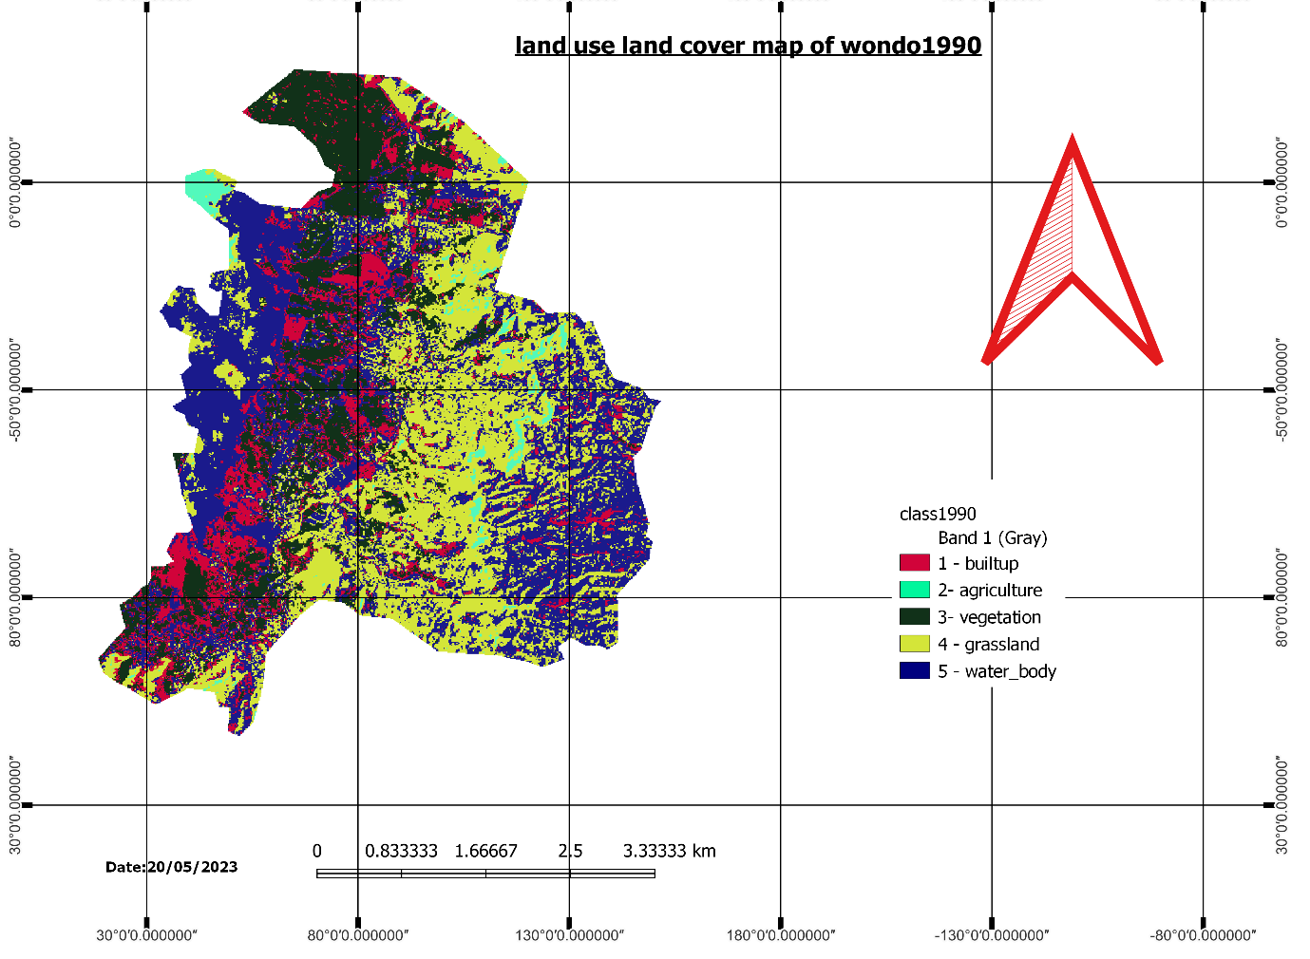

Figure 3: Land use land cover map of Wondogenet in 1990

|  |  |  |  |
| --- | --- | --- | --- |
| Class | Pixel Sum | Percentage % | Area [HA] |
| grassland | 590 | 36.23692 | 6996.06 |
| agriculture | 1253 | 19.65914 | 3795.48 |
| vegetation | 1412 | 30.59119 | 5906.07 |
| buildup | 4145 | 11.7912 | 2276.46 |
| Waterbody | 5000 | 1.72155 | 332.37 |
| TOTAL AREA | 12400 | 100 | 19306.44 |

Table 2: LULC Class Distributions of Wondogenet in 1990

According to the table 2 in 1990 classification result land use land cover classes were grassland, agriculture,vegetation,builtup and Waterbody. As indicated in (Figure 3) the greatest share of land use/land cover from all classes is grassland, which covers an area of 22764.6ha, agriculture covers an area of 332.37ha,vegetation covers an area of 3795.48ha, buildup covers an area size of 5906.07ha, and Waterbody covers an area size of 6996.06ha, respectively.

The least area coverage is agriculture and vegetation, which has only 332.37ha and 3795.48ha respectively from the total area. This shows that 39794.58ha of the total area of the district was covered by grassland, agriculture,vegetation,builtup and Waterbody in 1990.

## Landsat 8 Data for 2012 Images

NASA successfully launched the Landsat Data Continuity Mission on February 11, 2013. The satellite was renamed Landsat 8 and operation has been transferred to the USGS. Data collected since April 11, 2013 by the Operational Land Imager (OLI) and Thermal Infrared Sensor (TIRS) on board Landsat 8 are available for download. Of its 11 bands, only those in the very shortest wavelengths (bands 1–4 and 8) sense visible light –all the others are in parts of the spectrum that we can’t see. The true-color view from Landsat is less than half of what it sees. As a result, the images need to be contrast enhanced (stretched). Following this recommendation histogram equalization has run to enhance the image and a good result was found. After seven bands of the Landsat 8 (excluding thermal band) were considered for layer stacking, Landsat 8 band 5, 4 and 3 were combined to make conventional false color compositeImageswithaspatialresolutionof30meters.[(http://www.eoearth.org/view/article/150964/](http://www.eoearth.org/view/article/150964/)

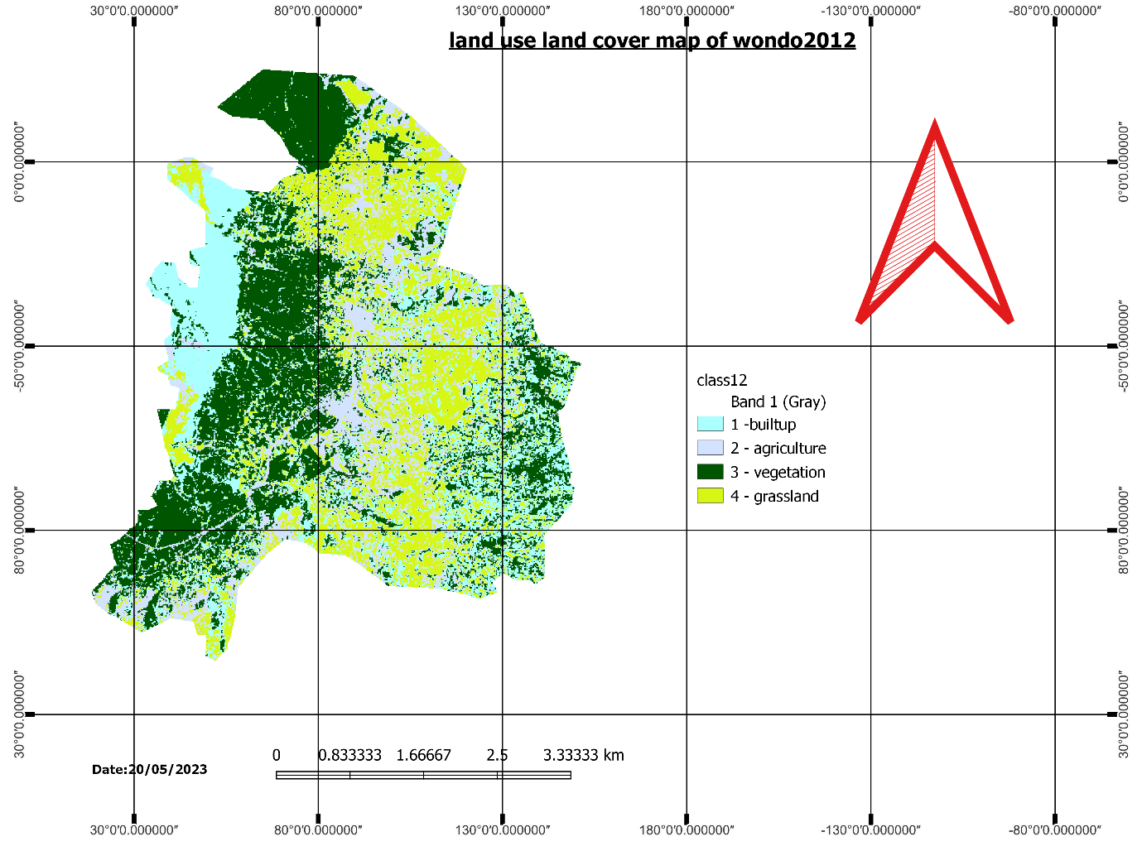

Figure 4: Land use land cover map of Wondogenet in 2012

|  |  |  |  |
| --- | --- | --- | --- |
| Class | Pixel Sum | Percentage % | Area [HA] |
| Grassland | 4112 | 24.29562 | 4690.62 |
| Agriculture | 3207 | 17.57491 | 3393.09 |
| Vegetation | 5120 | 33.29728 | 6428.52 |
| Buildup | 4323 | 24.83218 | 4794.21 |
| TOTAL AREA | 16762 | 100 | 19306.44 |

Table 4: LULC Class Distribution of wondogenet in 2012

According to the above (table 4) in 2012 result of land use/land cover classes include grassland, agriculture, vegetation and buildup but all the land use classes have different area coverage from the previous time. As indicated in (Figure4) the greatest share of land use/ land cover from all classes is vegetation, which covers 6428.52ha. Buildup, grassland, agriculture which covers 4794.21ha, 4690.62ha, and 3393.09ha respectively.

## Landsat 8 Data for 2023 Images

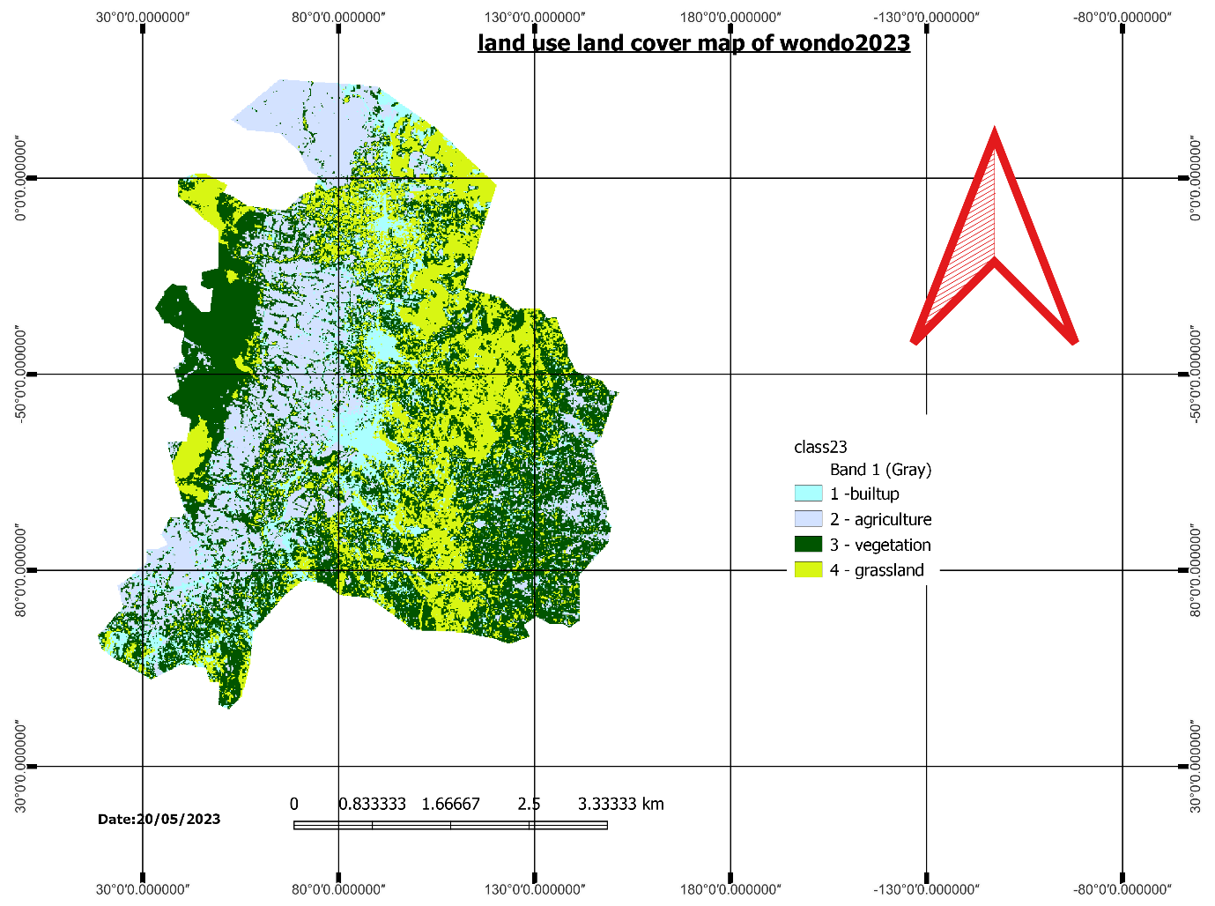

Table 5: LULC Class Distribution of wondogenet in 2023

|  |  |  |  |
| --- | --- | --- | --- |
| Class | Pixel Sum | Percentage % | Area [HA] |
| Grassland | 6649 | 24.01406 | 4636.26 |
| Agriculture | 3878 | 21.61098 | 4172.31 |
| Vegetation | 6305 | 41.89151 | 8087.76 |
| Buildup | 1357 | 12.48345 | 2410.11 |
| TOTAL AREA | 18189 | 100 | 19306.44 |

Table 5: LULC Class Distribution of wondogenet in 2023

According to the above (table 5) in 20223 result of land use/land cover classes include grassland, agriculture, vegetation and buildup but all the land use classes have different area coverage from the previous time. As indicated in (Figure5) the greatest share of land use/ land cover from all classes is vegetation, which covers 8087.76ha. Buildup, grassland, agriculture which covers 2410.11ha, 4636.26ha, and 4172.31ha respectively.

### LAND USE LAND COVER CHANG ANALYSIS

As it is indicated in the above LULC map of the study area there were changes about land classes of the town. In order to mapping the LULC map of study area .A supervised classification of images was approved using the maximum likelihood method. This decision rule is based on the probability that a pixel belongs to a particular class with the highest probability among of several possibilities. All the satellite data were thoroughly studied using spectral and spatial profiles to ascertain the digital numbers (DNs) of different land cover types prior to classification. Training samples were selected through reference data and ancillary information which have mentioned earlier. A supervised maximum likelihood classification (MLC) algorithm was subsequently applied to each image which has generally proven to obtain the best results from remotely-sensed data if each class has a Gaussian distribution (Bolstad and Lillesand 1991). Post-classification refinement therefore was used to improve the accuracy as it is simple, efficient and easily executable method (Harris and Ventura 1995). A 3x3 majority filter finally applied to the classified land cover data to reduce the salt-and pepper effect according to Lillesand and Kiefer, s recommendation. To determine the changes in land use/cover at different time, a post classification comparison of change detection was used. Even though this technique presents

advantage of post classification comparison is that it by passes the difficulties associated with the analysis of images acquired at different times of the year and/or by different sensors (Yuan et al. 2005; Coppin et al. 2004; Alpha 2003). Moreover, the post classification method also answers the amount, location, and nature of change (Howarth and Wickware 1981). A comparison between the classified maps was carried out subsequently on a pixel-by-pixel basis (Jensen and Ramsey 1987). In this study, post-classification change detection technique was applied. Post classification is the most obvious method of change detection, which requires the comparison of independently produced classified images. Post-classification comparison proved to be the most effective technique, because data from two dates are separately classified, thereby minimizing the problem of normalizing for atmospheric and sensor differences between two dates. Cross-tabulation analysis was carried out to analyze the spatial distribution of different land cover classes and land cover changes. The classified images were further smoothed with a 'majority filter' with a 3 x 3 kernel to eliminate 'fine' noise. Eventual class-based accuracy assessments for the analysis were performed by preparation of the contingency matrix for the classified images.

An increasingly interesting application of remotely sensed data in the context of land cover pattern classification is for the analysis of land cover changes over time. According to Land sat Images, the five land cover classes (1990), the four land cover (2012) and four land cover class (2023) defined as the main classes. Land-use and -cover change (LULC) are among the most important alterations of the Earth's land surface. Consequently, understanding and predicting the causes, processes and consequences of LUCC has become a major challenge to anyone involved in landscape ecology, regional land-use (LU) planning. Post classification comparison can be effective method when it has to express the specific nature of changes compiled with statistics in terms of tables or change maps. In this study both images of 19960, 2012and 2023 were classified successfully which are comparable and could easily identify areas where the changes have occurred related to the maps as well as from graph (Fig.) and tables.

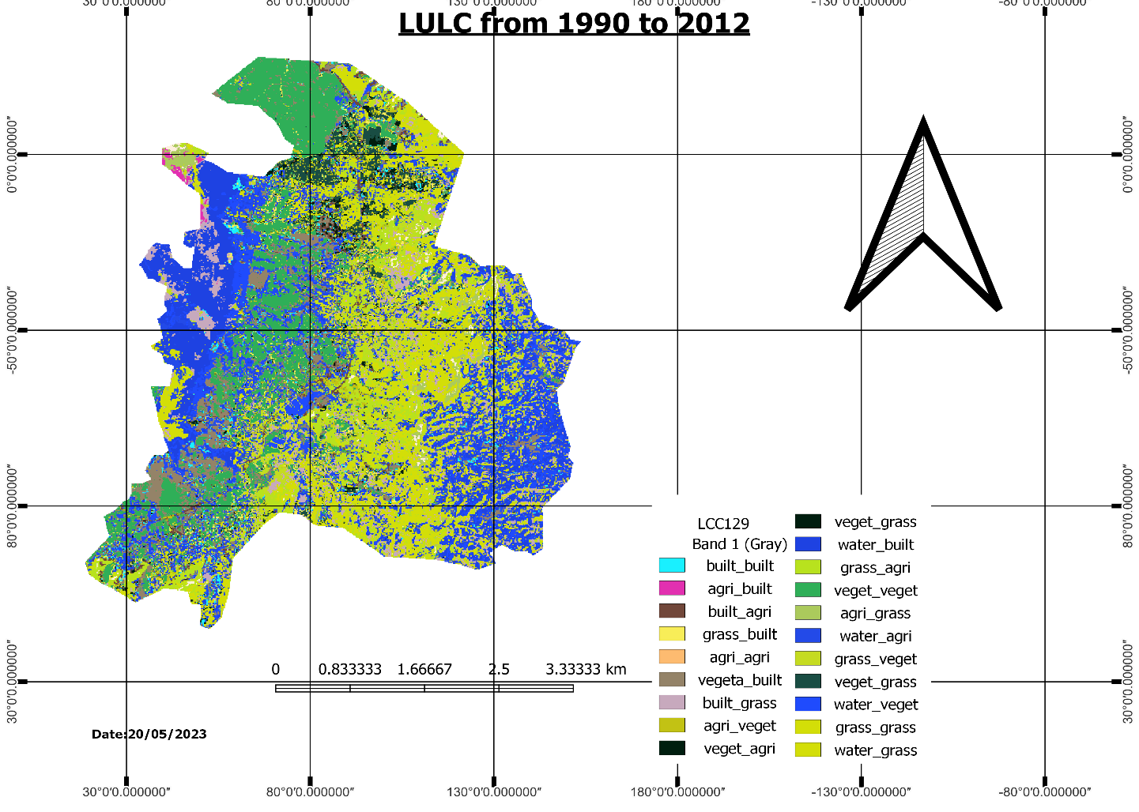

Figure 6: Land use land cover change map of wondogenet woreda from 1990 to 2012

|  |  |  |  |  |  |  |  |  |
| --- | --- | --- | --- | --- | --- | --- | --- | --- |
|  |  | LULCC1990 TO 2012 | | | |  |  |  |
|  |  | 1990 |  | 2012 |  |  |  |  |
| No | class name | area_ha | percentage | area_ha | percentage | area of 1990 to 2012 | rate | rate% |
| 1 | built-up | 2276.46 | 11.791195 | 4794.21 | 24.83218035 | 2517.75 | 114.4431818 | 52.516473 |
| 2 | agriculture | 332.37 | 1.7215499 | 3393.09 | 17.57491283 | 3060.72 | 139.1236364 | 90.20450386 |
| 3 | vegetation | 3795.48 | 19.65914 | 6428.52 | 33.29728319 | 2633.04 | 119.6836364 | 40.95872767 |
| 4 | grassland | 5906.07 | 30.591191 | 4690.62 | 24.29562364 | -1215.45 | -55.2477273 | -25.91235274 |
| 5 | waterbody | 6996.06 | 36.236924 |  |  | -6996.06 | -318.002727 |  |
|  | total | 19306.44 |  | 19306.44 |  | 0 | 0 |  |

Table 6: LULC Conversion matrix for the year 1990 to 2012

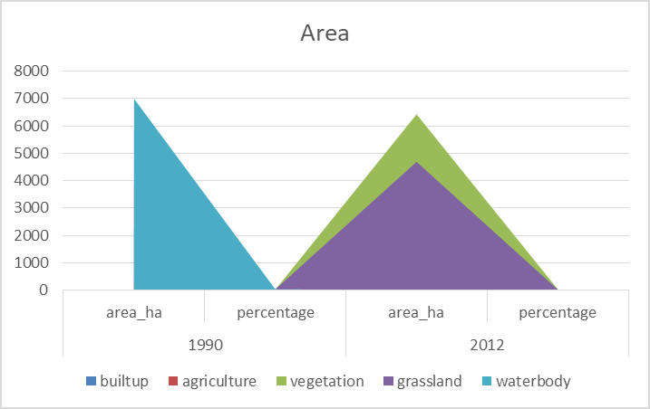

Figure: area as chart

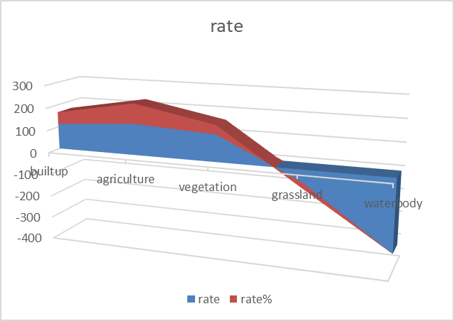

Figure:rate as chart

Generally there is a continuous land use/land cover change taking place for most parts of the study area in the last 22years.

For instance in 1990 buildup area were 2276.46hectares (11.79%) which gradually increase to 4794.21 hectares (24.83%) in 2012which indicate that (2517.75ha) increase within 22 years interval and vegetation shows increase from 3795.48hectare (19.66%) in 1990 to 6428.52

Hectares (33.3%) in 2102 which indicates that (13.64%) increase within 22 years interval (1990-2012).grassland area were 5906.07hectares (30.59%) which gradually decrease to 4690.62hectares (24.3%) in 2012which indicate that (-1215.45ha) decrease within 22 years interval. 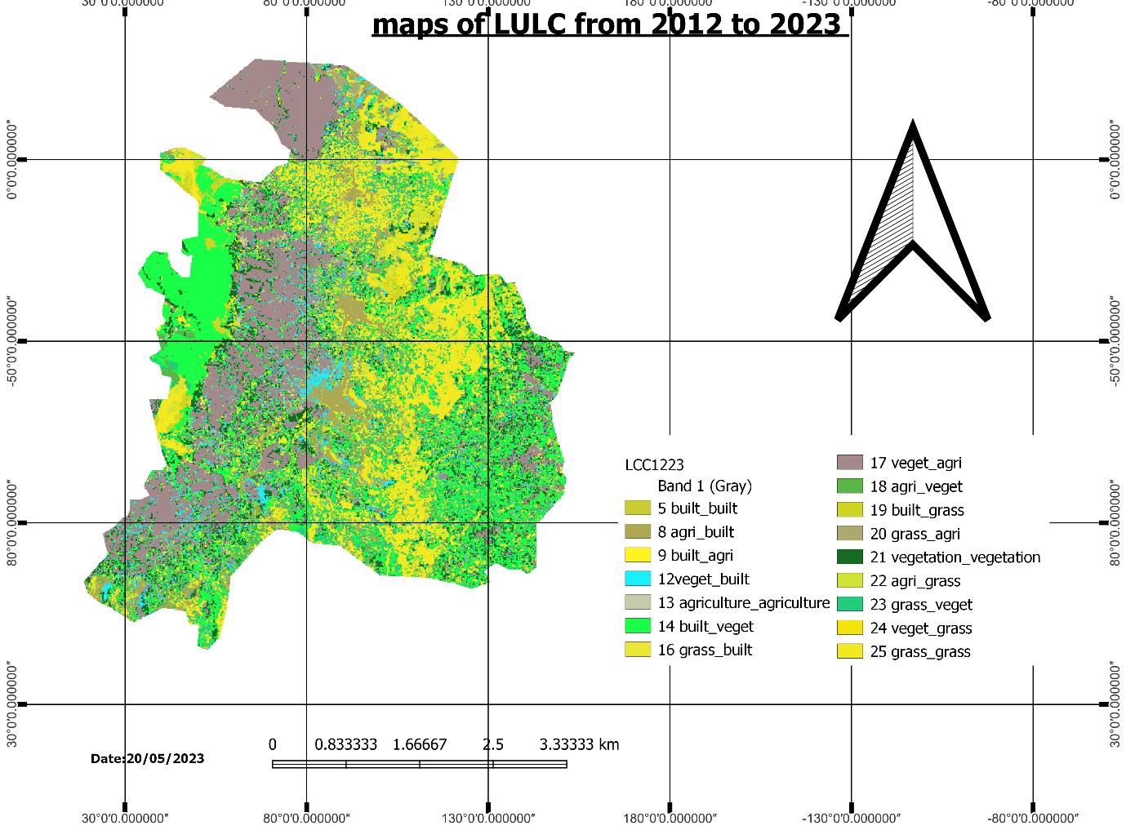

Figure 7: Land use land cover change map of wondogenet woreda from 2012 to 2023

|  |  |  |  |  |  |  |  |  |
| --- | --- | --- | --- | --- | --- | --- | --- | --- |
|  |  | LULCC2012 TO 2023 | | | |  |  |  |
|  |  | 2023 |  | 2012 |  |  |  |  |
| No | class name | area_ha | percentage | area_ha | percentage | area of 1990 to 2012 | rate | rate% |
| 1 | built-up | 2410.11 | 9.163045 | 4794.21 | 24.83218 | 2384.1 | 108.3682 | 49.72874 |
| 2 | agriculture | 4172.31 | 15.86279 | 3393.09 | 17.57491 | -779.22 | -35.4191 | -22.9649 |
| 3 | vegetation | 8087.76 | 30.74902 | 6428.52 | 33.29728 | -1659.24 | -75.42 | -25.8106 |
| 4 | grassland | 4636.26 | 17.62669 | 4690.62 | 24.29562 | 54.36 | 2.470909 | 1.158909 |
|  | total | 26302.5 |  | 19306.44 |  |  |  |  |

Table7: LULC Conversion matrix for the year 2012to 2023

Generally there is a continuous land use/land cover change taking place for most parts of the study area in the last 22years.

For instance in 2012 buildup area were 2410.11hectares (9.16%) which gradually increase to 4794.21hectares (24.83%) in 2023which indicate that (2384.1ha) increase within 22 years interval and vegetation shows increase from 8087.76hectare (30.75%) in 2012 to 6428.52

Hectares (33.3%) in 2023which indicates that (2.56%) increase within 22 years interval (2023_2012).grassland area were 4636.26hectares (17.63%) which gradually increase to 4690.62hectares (24.3%) in 2012which indicate that (54.36) increase within 22 years interval.

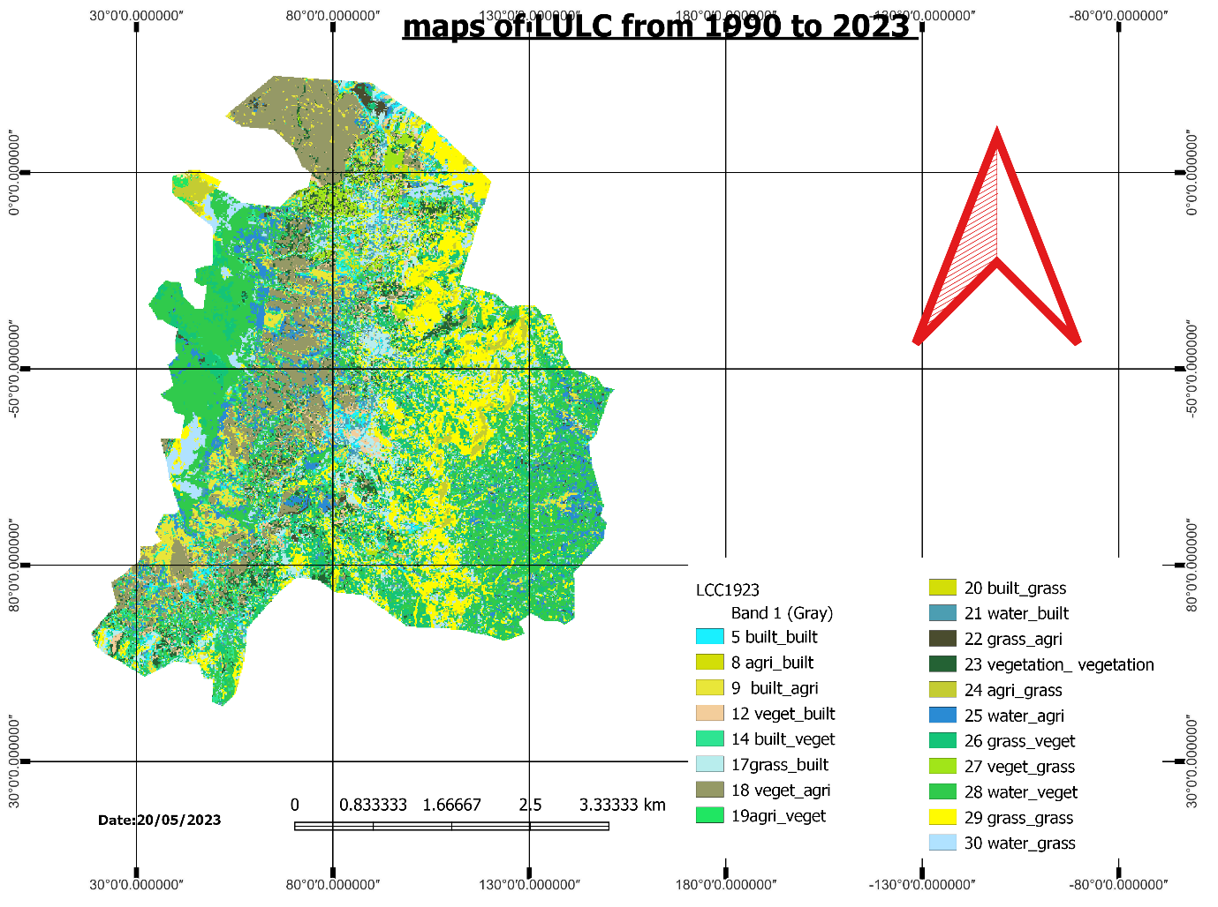

Figure 8: Land use land cover change map of wondogenet woreda from 2012 to 2023

|  |  |  |  |  |  |  |  |  |
| --- | --- | --- | --- | --- | --- | --- | --- | --- |
|  |  | LULCC1990 TO 2023 | | | |  |  |  |
|  |  | 1990 |  | 2023 |  |  |  |  |
| No | class name | area_ha | percentage | area_ha | percentage | area of 1990 to 2012 | rate | rate% |
| 1 | built-up | 344.52 | 7.1861683 | 2410.11 | 12.4834511 | 2065.59 | 93.89045455 | 85.705217 |
| 2 | agriculture | 41.58 | 0.8672962 | 4172.31 | 21.6109754 | 4130.73 | 187.7604545 | 99.00343 |
| 3 | vegetation | 313.2 | 6.5328803 | 8087.76 | 41.8915139 | 7774.56 | 353.3890909 | 96.127482 |
| 4 | grassland | 1134 | 23.653532 | 4636.26 | 24.0140596 | 3502.26 | 159.1936364 | 75.54063 |
| 5 | waterbody | 2960.91 | 61.760123 |  |  | -2960.91 | -134.586818 |  |
|  | total | 4794.21 |  | 19306.44 |  | 14512.23 | 659.6468182 |  |

Table8: LULC Conversion matrix for the year 2012to 2023

Generally there is a continuous land use/land cover change taking place for most parts of the study area in the last 22years.

For instance in 1990 buildup area were 344.52hectares (7.19%) which gradually increase to 2410.11hectares (12.48%) in 2023which indicate that (2065.59ha) increase within 33years interval and vegetation shows increase from 313.2hectare (6.53%) in 1990 to 8087.76

Hectares (41.89%) in 2023which indicates that (7774.56ha)increase within 33 years interval (1990_2023).grassland area were 1134hectares (23.65%) which gradually increase to 4636.26hectares (24.01%) in 2023which indicate that (3502.26ha) increase within 33 years interval.

## Major Causes of LULCC

### Natural Variability

Natural environmental changes interact with the human decision making processes that cause land-use change. Highly variable ecosystem conditions driven by climatic variations amplify the pressures arising from high demands on land resources, especially under resource-limiting conditions, such as dry to sub-humid climatic conditions. Though natural and socioeconomic changes may operate independently, natural variability may also lead to socioeconomic unsustainability, for example when unusually wet conditions alter the perception of drought risks and generate overstocking on rangelands. The livestock management practices are ill adapted and cause land degradation. Land-use change, such as cropland expansion in dry lands, may also increase the vulnerability of human-environment systems to climatic fluctuations and thereby trigger land degradation.

### Demographic Factors

Both increases and decreases in local populations have large impacts on land use. Demographic changes include not only shifts in fertility and, but also changes in household structure and dynamics, including labor availability, migration, urbanization, and the breakdown of extended families into multiple nuclear families.

### Cultural Factors

The motivations, collective memories, personal histories, attitudes, values, beliefs, and individual perceptions of land managers influence land-use decisions, sometimes profoundly. The intended and unintended ecological consequences of land-use decisions all depend on the knowledge, information, and management skills available to land managers, and these in turn are often linked to political and economic conditions, policies, social learning, and social resilience in the face of land-use change.

## DISCUSSION

Change in land use and land cover may result in forest clearance and land degradation that manifests in many ways depending on the magnitude of changes. For example, increase in demand for wood, urbanization and fodder, reduction of biodiversity, reduced land productivity, low-income generation capacity, influence in microclimate, water courses drying up, soil erosion incidences and gully .All of these manifestations have potential impacts on land users who rely on the products and services from a healthy landscape for their living.

The land use and land cover changes that were detected in all study areas revealed, in general, the greater areas of forest land, farm land and bare land were transformed into settlement/built up. The latter definitely imply how changes inland use and land cover causes land degradation. Rapid population growth, new resettlement programs and poor land administration were identified as the driving forces for the dramatic expansion of settlement/built up in space and time.

# Conclusion and Recommendation

## Conclusion

The study has clearly demonstrated the potential of multi temporal Land sat data and GIS in studying the land use and land cover dynamics. They are also useful tools to establish a decision support system and have paramount importance for natural resource management and planning. The result of this study shows the existence of significant land use and land cover changes in the last 22 years. Especially the expansion of Built up following vegetation, agriculture and bare land were decreased. The socio economic survey conducted also revealed that population growth is the major cause for land use/ land cover change and this factor is also supported from the analysis that land scarcity was happening in the study area following the growth of population.

## RECOMMENDATIONS

Land use/land cover mapping and detection of changes shown here may not provide the ultimate explanation for all problems related to land use/land cover changes but it serves as a base to understand the patterns, trend of changes and possible causes and consequences of land use/land cover changes in the area. Since most important factor of the land use / land cover change in the study area was an increase in population, continuing the efforts of introducing family planning to make the people aware of consequences of population pressure on land resources should be carried out intensively. Remote sensing satellite imagery is widely applicable for land use and land cover classification and change detection. This is an important input in land use planning and other development activity. Hence, remote sensing and GIS should be utilized for natural resource management to describe the managers and decision makers themselves with up to-date information and experts at the town level should be trained on a skill of remote sensing and GIS to provide tangible timely information to the decision makers at the lowest administrative level. Land use/land cover mapping and detection of changes shown here may not provide the real figure of classes due to low resolution of the imagery but it serves as a base to understand the Ideas and magnitude of land use/land cover changes in the area. Therefore such land use/cover detections using high resolution satellite images would be more dependable.

# Reference

Ali Hussein, 2009.Land Use Land Cover Change, drivers and its impact: A comparative study

From kuhar Michael and Lench Dima of Blue Nile and Awash.

Ali Mohammed 2007, Girma et al. 2017; Hunde et al. 2003.

Andrew skid more, 2003.Environmental modeling with GIS and remote sensing, Taylor and

Francis, London and New York.

American museum of natural history, 2004.Remote sensing resources: RS and Geographic

Information facility.

A.W.Kuchler and I.S.Zonneveld, 1988.vegetation mapping: hand book of vegetation science.

Kluwer academic publisher, London.

Behailukebede, 2006.land cover land use change and agroforestry practice at pawe

Resettlement district, north western Ethiopia: Hawassa university WGCF_NR, Ethiopia: MSC thesis.

Diouf & Lambin, 2001; Millennium Ecosystem Assessment, 2005

E.F.Lambine, B.L. Turner, 2000.the causes of land use land cover change: moving beyond the myths. University of Louvain, Belgium.

E.F.Lambine, B.L and H.J.Geist, 2006.land use and land cover change: local processes and global impacts. University of Louvain Belgium

Erle Ellis, 2010.the encyclopedia of earth land use land cover change, university of Mary land.

Erle, F.Lambine, helmunt, J.Geist and Erika Lopers, 2003.dynamics of land use and land cover change in tropical regions, university of Louvain, Belgium.

(<http://landsat7.usgs.gov/>)

Nega emiru,HelufGebrekidan and Degefa Tibebe,2003.Analysis of land use land cover change in western Ethiopia mixed crop livestock system: In the case of senbat watershed. Addis Abeba University Ethiopia, (Otter man, 1974; Chaney and Stone, 1975; Sagan et al. 1979).

P.M. Mother, 2003.computer processing of remotely sensed images an introduction, 2nd edition Jhonwiley and sons’ ltd, England.

SRTM 30m.

Reusing, 2000; Tadesse, 2001; Biazin & Sterk, 2013

Robert T.Wateson, 2000.land use land cover change and forestry, intergovernmental panel on climate change: Cambridge University press united king Dom.Fishcher, G., Fresco, L.O.Leemans, and R. 1995. Land use and land cover change. Science/Research Plan IGBP report No, 35, HDP report No, 7 Stockholm. 132p.

Wondo Genet agency of agriculture and Kebele administration, 2011.

Zeleke & Hurni, 2001; Moges & Holden, 2009; Gebrehiwot et al., 2010; Biazin & Sterk, 2013

Zerihun, 1999; Teshale Woldeamanuel, 2003.